1.the following conditions exist: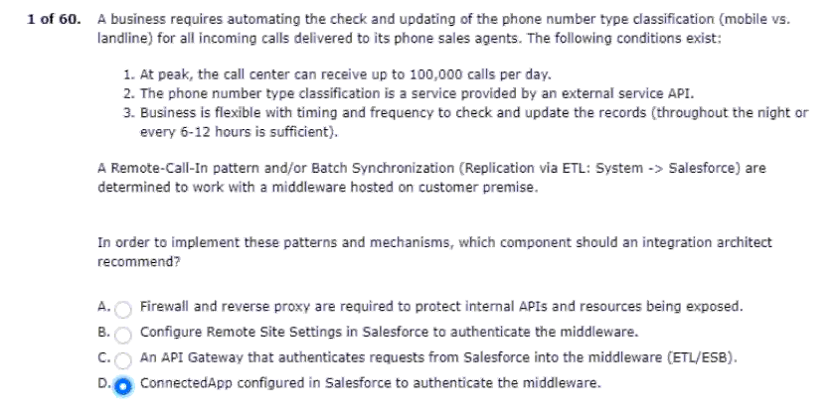
2.for customers who inquire about uc products.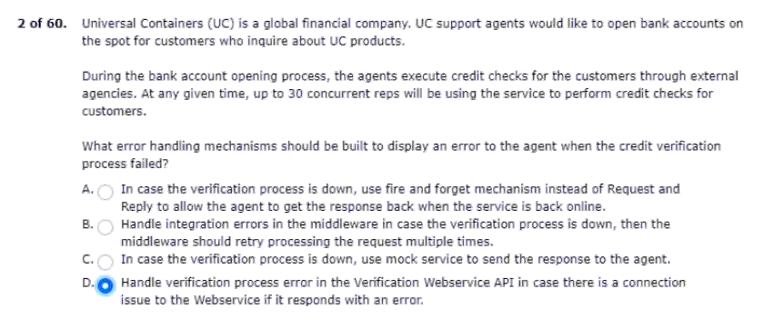
3.invoices from a given set of orders.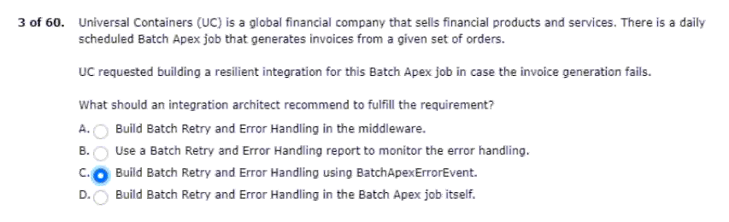
4.planning to implement salesforce sales cloud.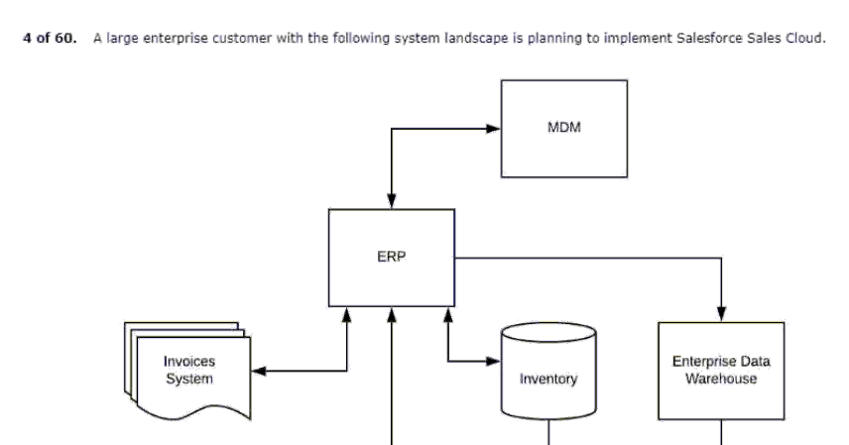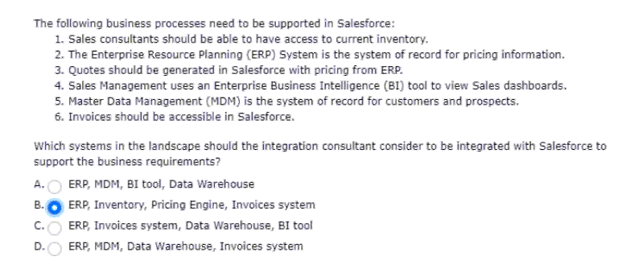
5.this system must remain on-premise.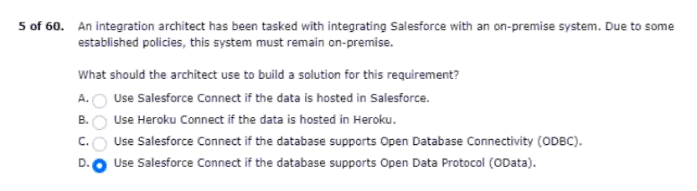
6.the current integration often experiences latency issues.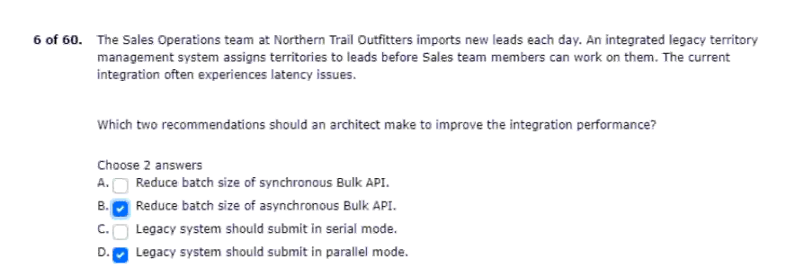
7.salesforce with an external system for a company.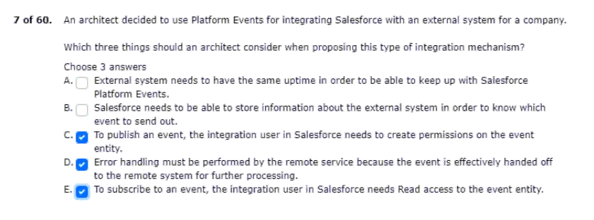
8.one salesforce org and different metadata?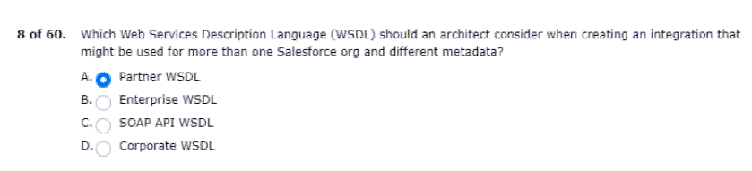

9.the event are as follows:
Will meet these business requirements?
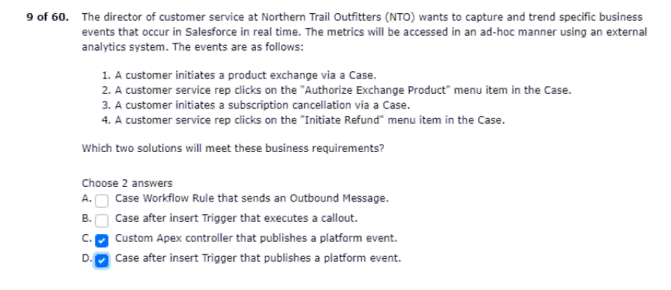
10.data needs to be reflected in the lms.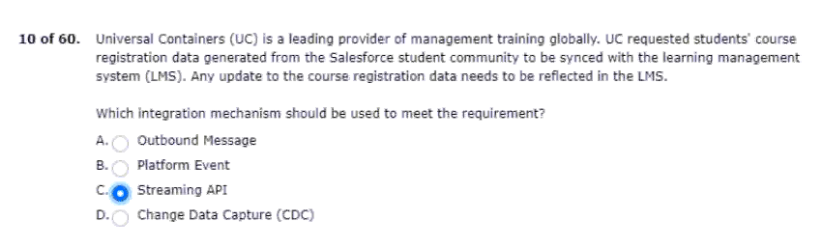
11.nto wants the data to only persist in the external system.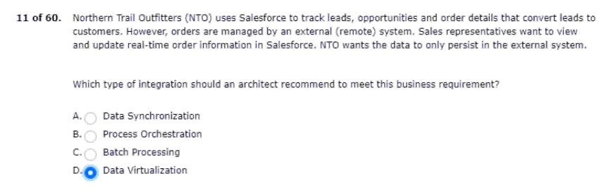
12.business critical function for end users.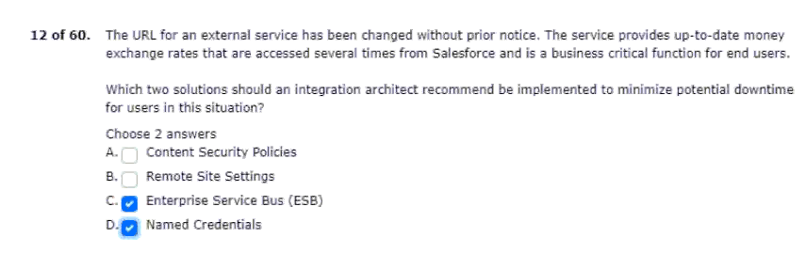
13.their internal systems and salesforce.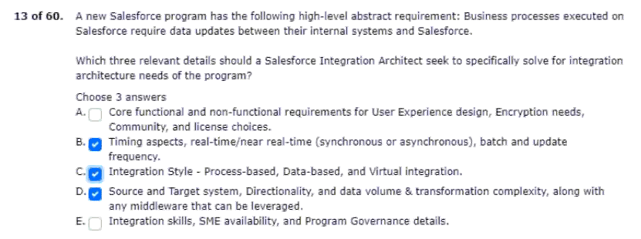
14.order to meet a business requirement.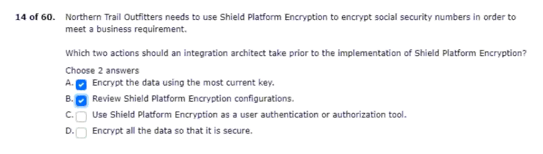

15.nto has the following requirements:
Recipe and data syncs.
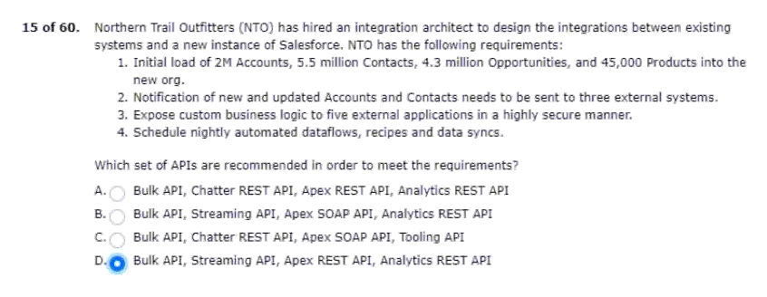
16.the current system landscape includes the following: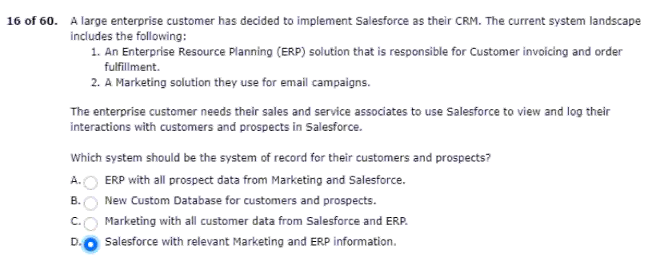
17.plans to include salesforce as well.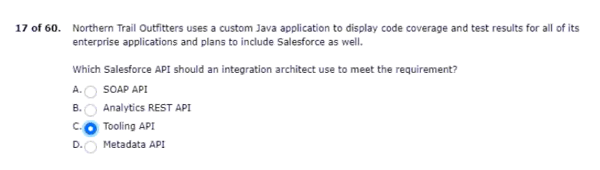
18.with on-premise resources and services.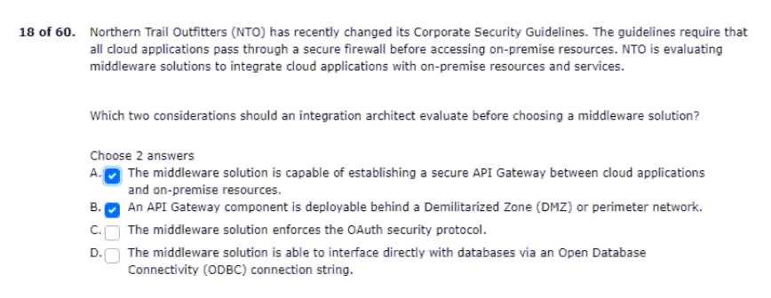
19.security and strict auditing requirements: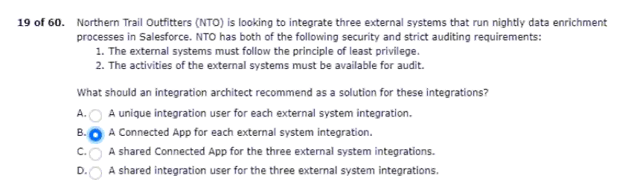
20.and request shipping estimates from that service.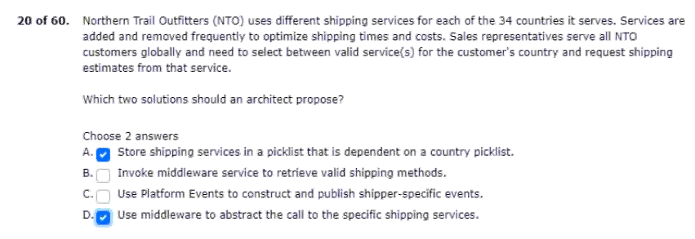
21.web component to an external endpoint is falling?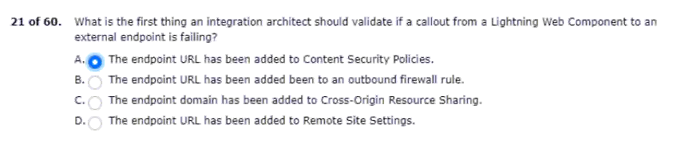
22.the system architect for some guidance.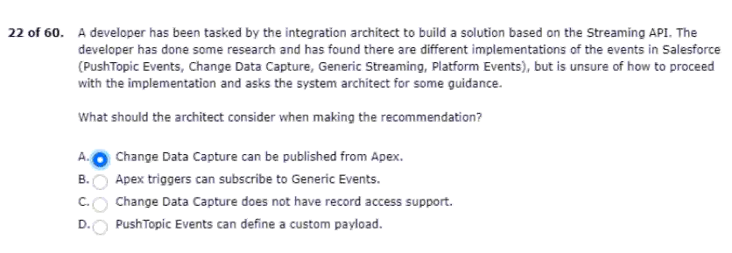
23.orders from salesforce to a fulfillment system?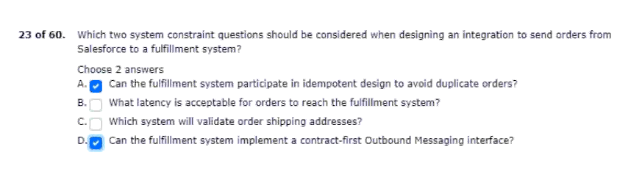
24.rest api to avoid architecture changes.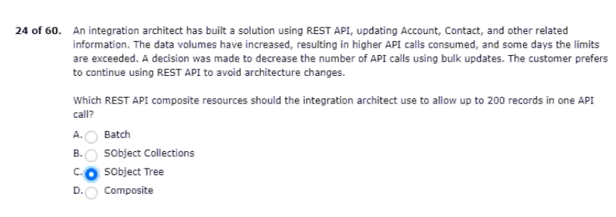
25.self-registration and sign-on(sso).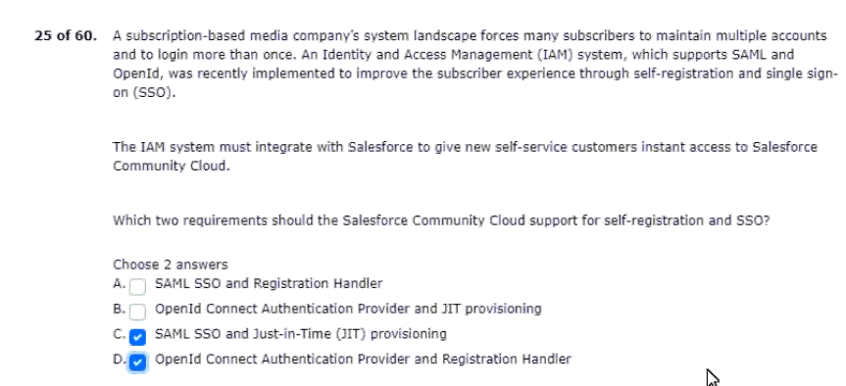
26.that apex rest api clients can rely on.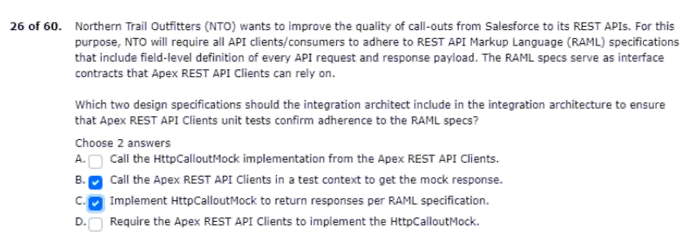
27.accounts using the lead-to-opportunity process.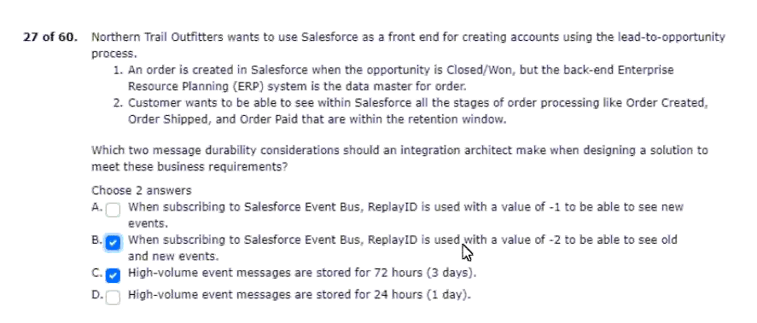
28.their current system landscape diagram.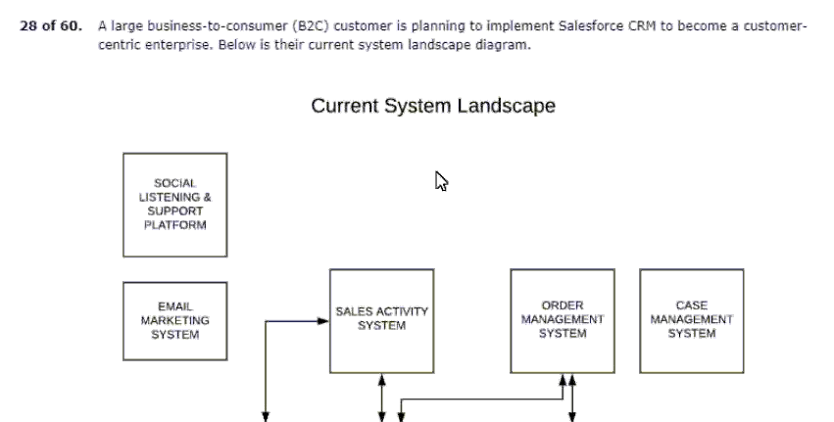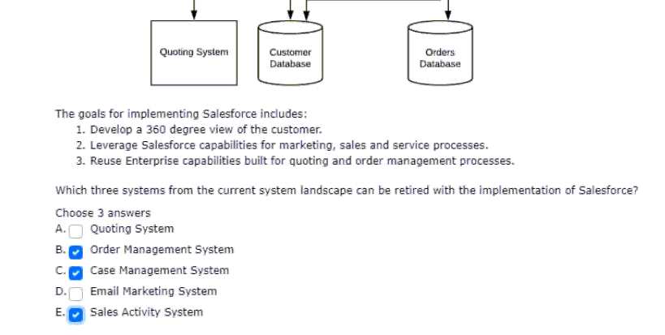
29.getting response back in a strongly-typed format.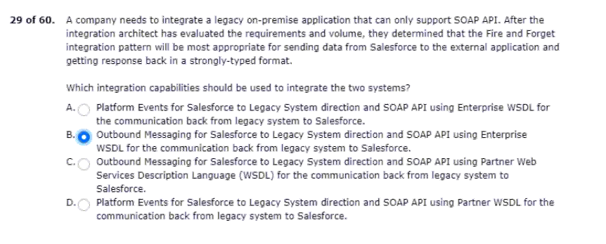
30.with their legacy application with salesforce.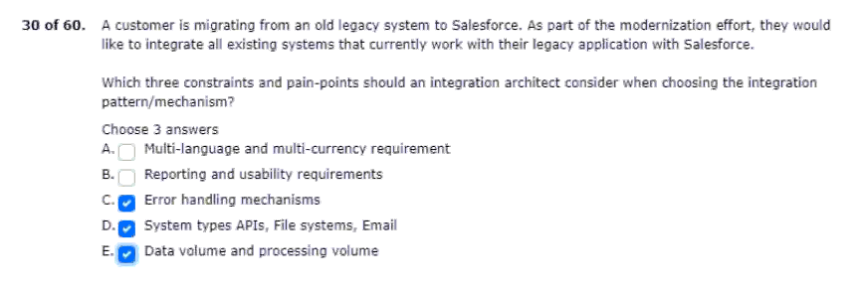
31.will be approximately 1 million contacts per month.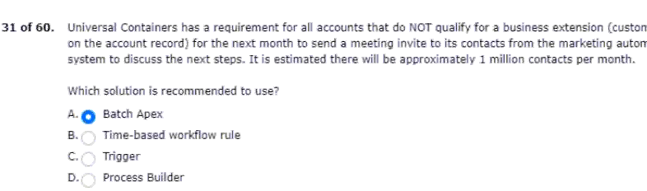
32.even when the client re-connects every couple of days.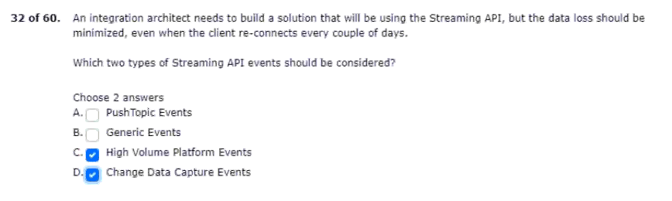
33.and services that include the following: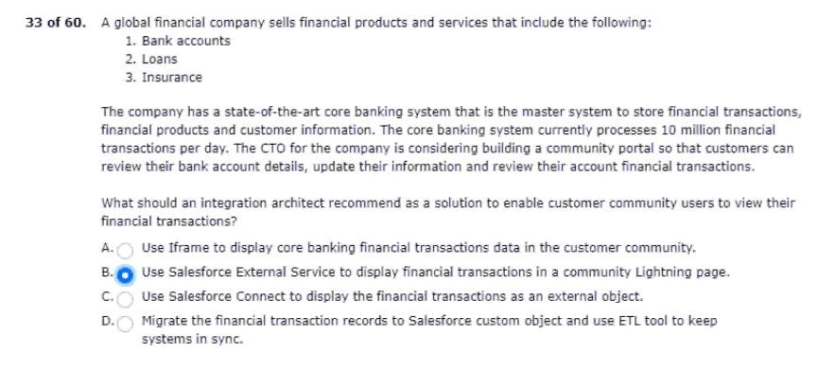
34.currently, uc has the following systems: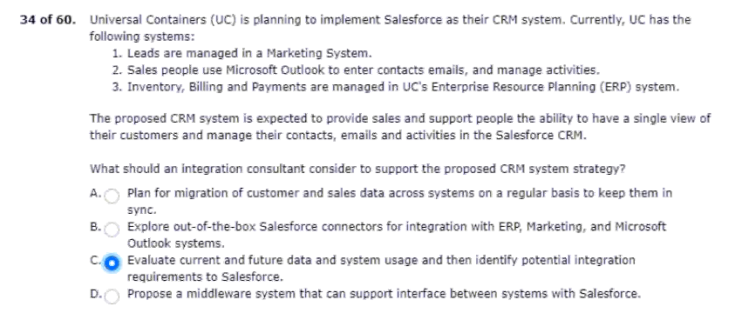
35.salesforce supports are critical to the business.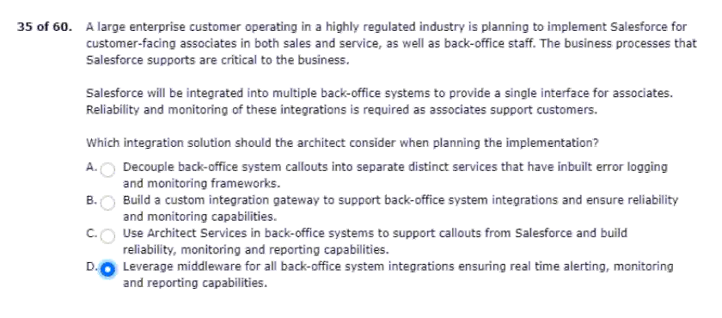
36.masters all courses and student registration.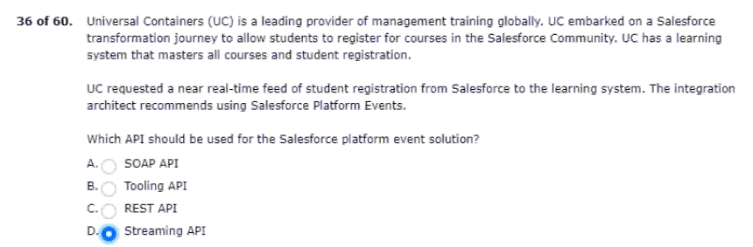
37.view the design files in the community.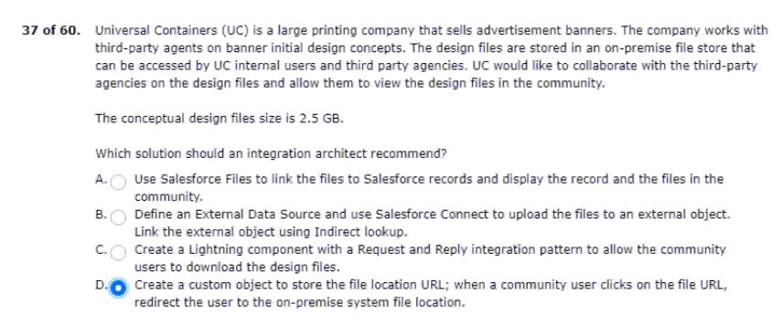
38.system will be taken down for maintenance.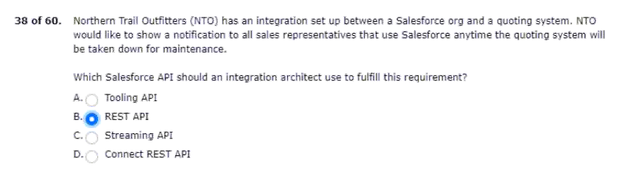
39.inventory during customer checkout process.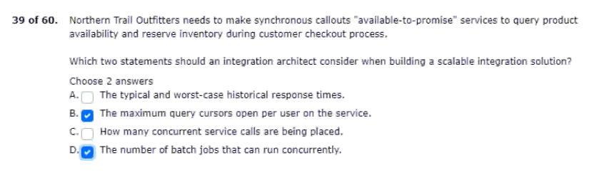
40.and store them on a custom geolocation field. 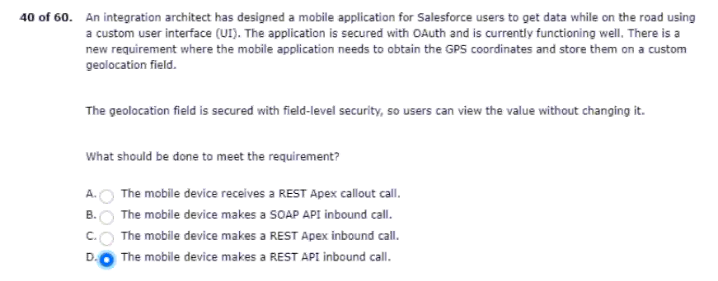
41.the company will complete the following: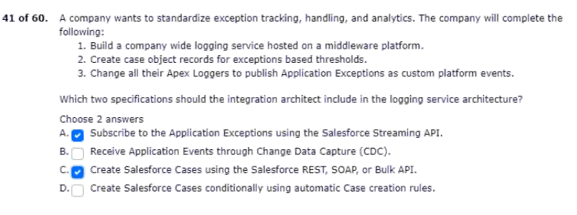
42.soql query filtered by sharing hierarchy.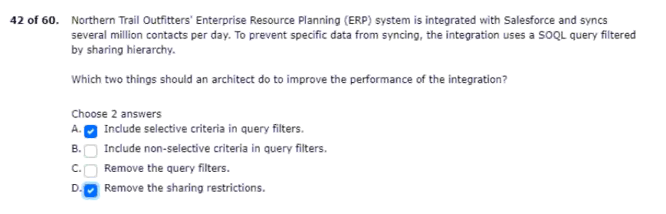
43.such aspects with their salesforce program.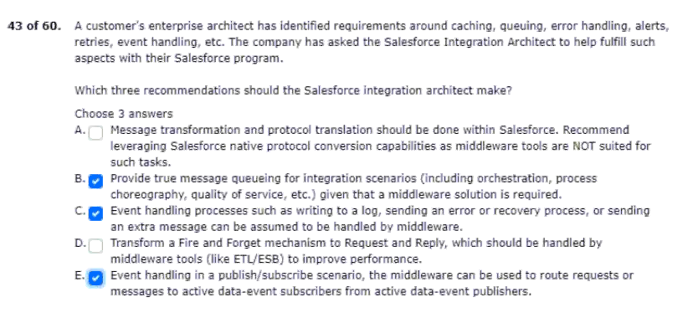
44.with limited outside access to external systems.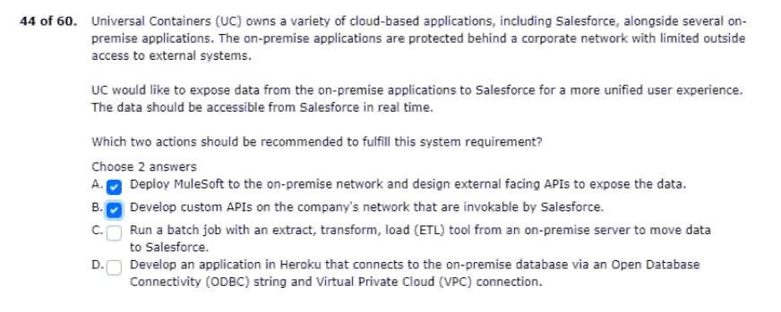
45.systems and salesforce platform limits.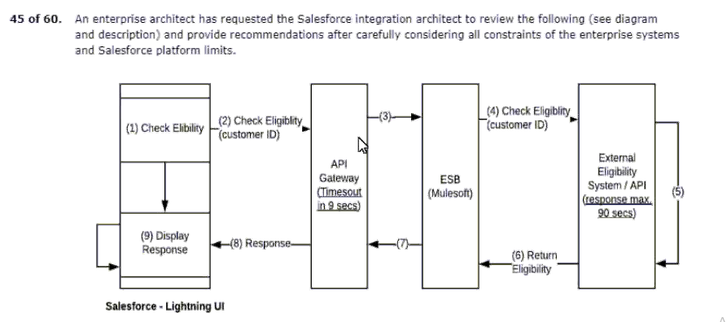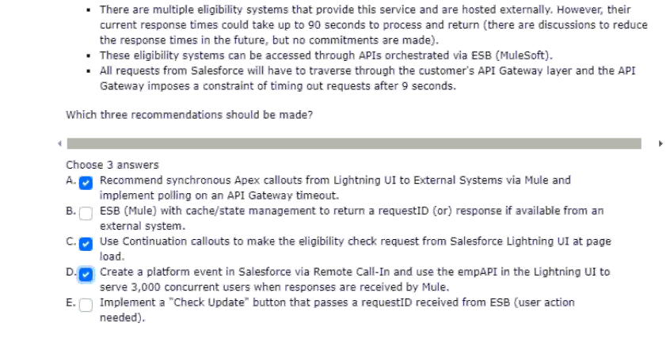
46.portal use ssl mutual authentication?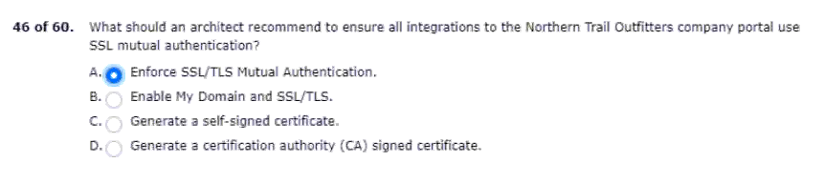

47.and oauth tokens used in callout from salesforce.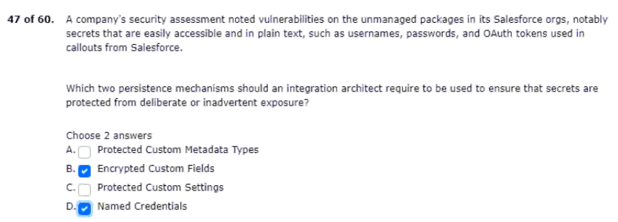
48.from salesforce to on-premise servers.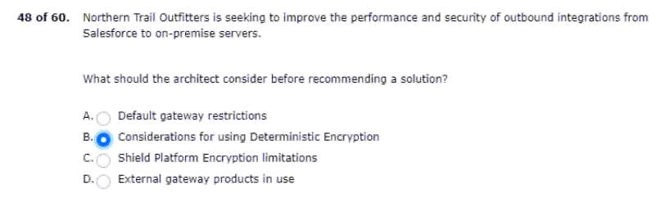
49.boolean and string values data types.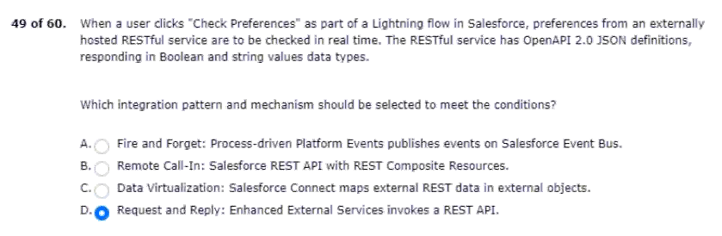
50.after installation of the package.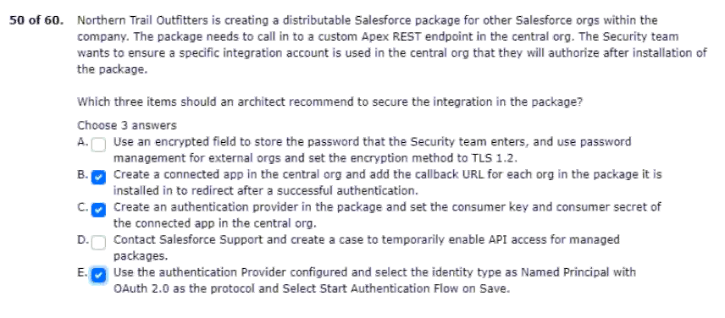
51.resources and requires a low-code solution.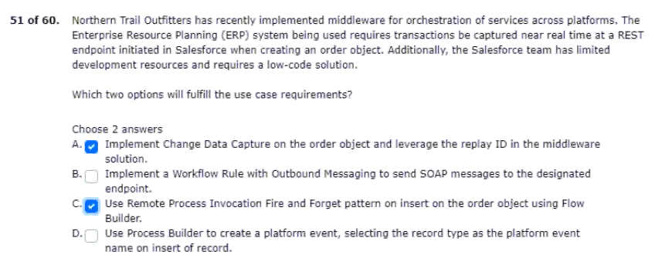
52.inquiring about uc bank accounts.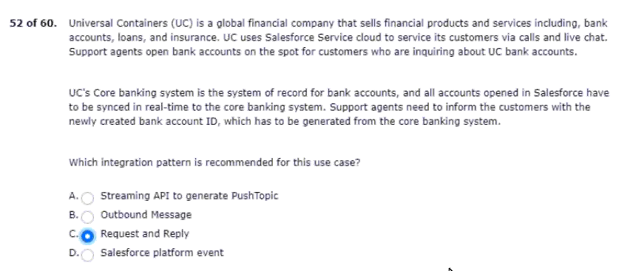
53.systems and conditions in their landscape: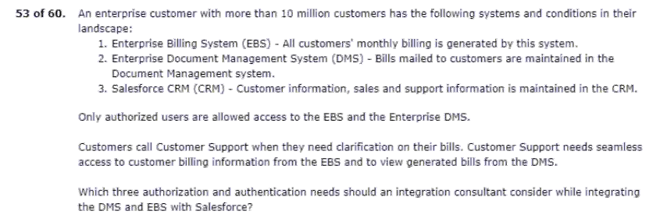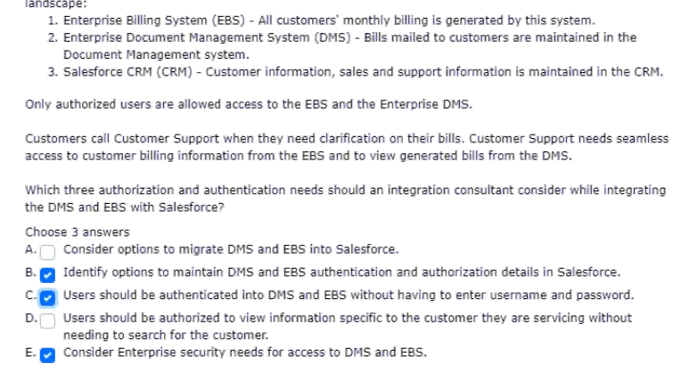
54.an apex callout due to technical constraints.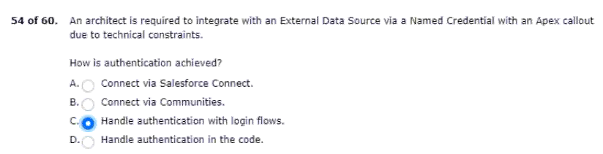
55.the students can retry the payment process.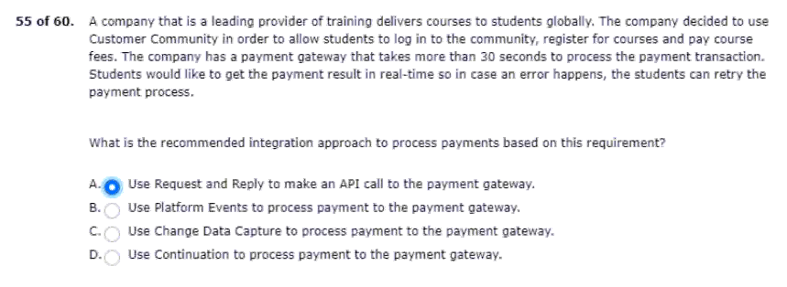
56.keeps them synchronised via platform events. 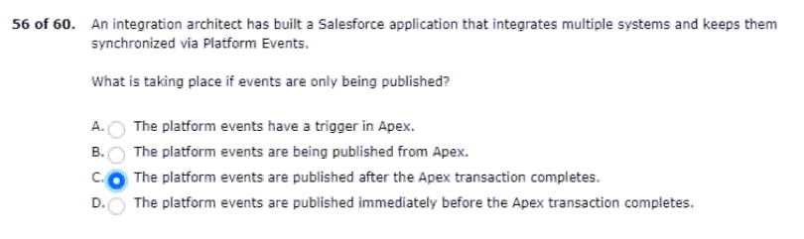
57.and has requested a solution recommendation.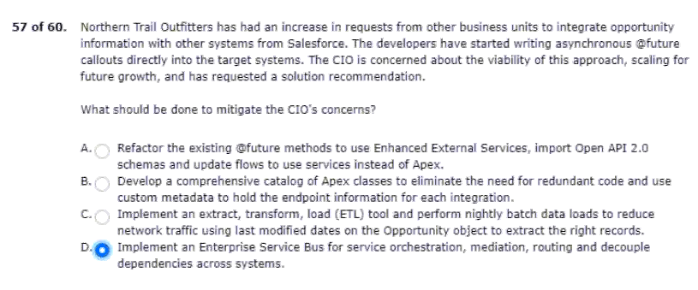
58.degradation in salesforce performance.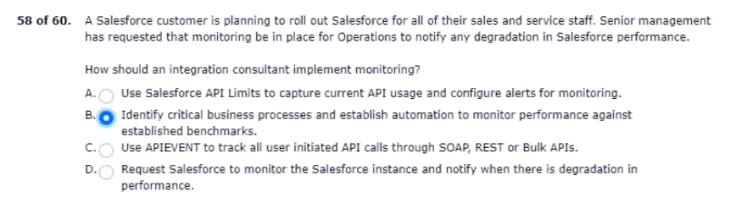
59.be kept synchronised for consistency.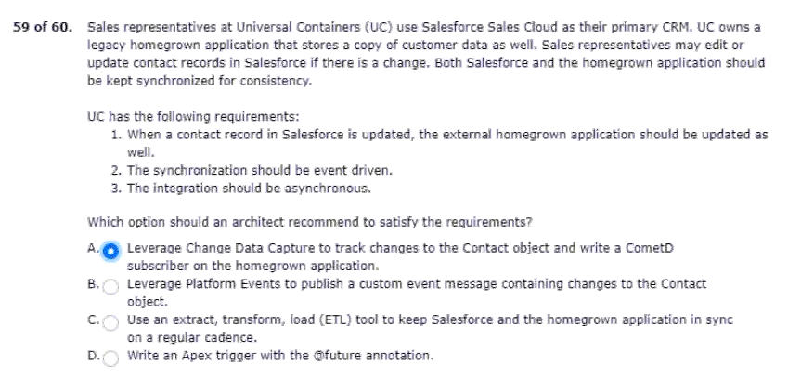
60.the number of closed cases in real time.